Name : M. SABARESWARI
Reg No : 411625149036
Department : B.E CSE ( Cyber Security )
Subject : WEB TECHNOLOGY
Batch : 05
TOPIC: Fitness & Gym Center Website
Aim
To design and develop a Fitness & Gym Center website using HTML that provides essential information about gym facilities, trainers, services, membership plans, testimonials, and contact details, enabling users to easily explore services and book memberships online.

Procedure – Fitness & Gym Center Website

Step 1: Creating the Basic HTML Structure
The project was initiated by creating multiple HTML files using the <!DOCTYPE HTML> declaration along with <html>, <head>, and <body> tags to define the basic structure of each webpag

Step 2: Setting Website Title and Favicon
The website title “PowerFit Gym” was set using the <title> tag inside the <head> section.
A gym logo was added as a favicon using the <link rel="icon"> tag to enhance the website identity.
Step 3: Designing the Home Page
The home page was designed using:
- <h1> to display the gym name
- <p> to describe the gym’s mission and fitness goals
- <img> to show the gym logo or fitness image
- A welcome message introducing gym facilities and training programs
Step 4: Implementing Navigation Menu
A navigation bar was added to all pages using <a> (anchor) tags to link:
- Home
- About
- Services
- Testimonial
- Contact
- Membership
This ensures smooth navigation across all sections of the website.
Step 5: Creating the About Page
The About page was created using:
- <table> to display trainer details such as name, qualification, experience, and specialization
- <img> tag to display the trainer’s photograph
- <ul> and <li> tags to list certifications, achievements, and experience
Step 6: Developing the Services Page
The Services page was designed to display gym facilities using:
- <ul> and <li> tags for services like weight training, cardio, yoga, and personal training
- <table> for structured presentation of fitness programs
Step 7: Creating the Testimonials Page
The Testimonials page includes:
- <table> to display member feedback
- <h3> tags for review text
- Radio buttons (<input type="radio">) to allow users to rate the gym services
Step 8: Designing the Contact Page
The Contact page was created using:
- Email and phone details
- <a href="mailto:"> and <a href="tel:"> for easy communication
- Address information displayed using a table
Step 9: Creating the Membership Registration Form
A membership form was designed using:
- <form> and <fieldset> tags
- Input fields for name, email, phone number, and membership plan
- <select> dropdown for choosing membership type
- Submit button for registration

Step 10: Adding Footer Section
- A footer was added to all pages using the <footer> tag to display copyright information and maintain uniformity throughout the website.

Step 11: Final Testing
All webpages were tested to verify:
- Proper linking between pages
- Correct display of text, images, and tables
- Smooth functioning of forms
- User-friendly layout and readability

CODE:

Home Page – index.html:

<!DOCTYPE html>
<html>
<head>
<title>PowerFit Gym</title>
</head>
<body>

<h1>PowerFit Gym & Fitness Center</h1>
<p>Transform your body. Transform your life.</p>

<h3>Navigate:</h3>
<a href="index.html">Home ></a>
<a href="about.html">About ></a>
<a href="services.html">Services ></a>
<a href="testimonials.html">Testimonials ></a>
<a href="contact.html">Contact ></a>
<a href="membership.html">Membership</a>

<h2>Welcome to PowerFit Gym</h2>
<p>
We provide world-class fitness training with certified trainers,
modern equipment, and personalized workout plans.
</p>

<footer>
<p>&copy; 2026 PowerFit Gym. All Rights Reserved.</p>
</footer>

</body>
</html>
About Page – about.html:
<!DOCTYPE html>
<html>
<head>
<title>About - PowerFit Gym</title>
</head>
<body>

<h3>Navigate:</h3>
<a href="index.html">Home ></a>
<a href="about.html">About ></a>
<a href="services.html">Services ></a>
<a href="testimonials.html">Testimonials ></a>
<a href="contact.html">Contact ></a>
<a href="membership.html">Membership</a>

<h2>About Our Trainer</h2>

<table border="1" cellpadding="10">
<tr>
<td>Name</td>
<td>Mr. Rahul Fitness Coach</td>
</tr>
<tr>
<td>Qualification</td>
<td>Certified Personal Trainer</td>
</tr>
<tr>
<td>Experience</td>
<td>8 Years</td>
</tr>
<tr>
<td>Specialization</td>
<td>Weight Loss, Bodybuilding, CrossFit</td>
</tr>
</table>

<footer>
<p>&copy; 2026 PowerFit Gym. All Rights Reserved.</p>
</footer>

</body>
</html>
Services Page – services.html:
<!DOCTYPE html>
<html>
<head>
<title>Services - PowerFit Gym</title>
</head>
<body>

<h3>Navigate:</h3>
<a href="index.html">Home ></a>
<a href="about.html">About ></a>
<a href="services.html">Services ></a>
<a href="testimonials.html">Testimonials ></a>
<a href="contact.html">Contact ></a>
<a href="membership.html">Membership</a>

<h2>Our Services</h2>

<ul>
<li>Personal Training</li>
<li>Weight Loss Programs</li>
<li>Muscle Building</li>
<li>Yoga & Meditation</li>
<li>Cardio Training</li>
<li>Diet & Nutrition Guidance</li>
</ul>

<footer>
<p>&copy; 2026 PowerFit Gym. All Rights Reserved.</p>
</footer>

</body>
</html>
Testimonials Page – testimonials.html:
<!DOCTYPE html>
<html>
<head>
<title>Testimonials - PowerFit Gym</title>
</head>
<body>

<h3>Navigate:</h3>
<a href="index.html">Home ></a>
<a href="about.html">About ></a>
<a href="services.html">Services ></a>
<a href="testimonials.html">Testimonials ></a>
<a href="contact.html">Contact ></a>
<a href="membership.html">Membership</a>

<h2>What Our Members Say</h2>

<table border="1" cellpadding="10">
<tr>
<td>"Best gym with friendly trainers!"</td>
<td>"Lost 10kg in 3 months!"</td>
<td>"Great atmosphere and equipment"</td>
</tr>
</table>

<h3>Rate Us</h3>
<form>
<input type="radio" name="rate"> 5
<input type="radio" name="rate"> 4
<input type="radio" name="rate"> 3
<br><br>
<input type="submit">
</form>

<footer>
<p>&copy; 2026 PowerFit Gym. All Rights Reserved.</p>
</footer>

</body>
</html>
Contact Page – contact.html:
<!DOCTYPE html>
<html>
<head>
<title>Contact - PowerFit Gym</title>
</head>
<body>

<h3>Navigate:</h3>
<a href="index.html">Home ></a>
<a href="about.html">About ></a>
<a href="services.html">Services ></a>
<a href="testimonials.html">Testimonials ></a>
<a href="contact.html">Contact ></a>
<a href="membership.html">Membership</a>

<h2>Contact Us</h2>

<table border="1" cellpadding="10">
<tr>
<td>Email</td>
<td>powerfitgym@gmail.com</td>
</tr>
<tr>
<td>Phone</td>
<td>+91 9876543210</td>
</tr>
<tr>
<td>Address</td>
<td>Chennai, Tamil Nadu</td>
</tr>
</table>

<footer>
<p>&copy; 2026 PowerFit Gym. All Rights Reserved.</p>
</footer>

</body>
</html>
Membership / Appointment – membership.html:
<!DOCTYPE html>
<html>
<head>
<title>Membership - PowerFit Gym</title>
</head>
<body>

<h3>Navigate:</h3>
<a href="index.html">Home ></a>
<a href="about.html">About ></a>
<a href="services.html">Services ></a>
<a href="testimonials.html">Testimonials ></a>
<a href="contact.html">Contact ></a>
<a href="membership.html">Membership</a>

<h2>Join Our Gym</h2>

<form>
Name: <input type="text"><br><br>
Email: <input type="email"><br><br>
Phone: <input type="text"><br><br>

Membership Plan:
<select>
<option>Monthly</option>
<option>Quarterly</option>
<option>Yearly</option>
</select>
<br><br>

<input type="submit" value="Join Now">
</form>

<footer>
<p>&copy; 2026 PowerFit Gym. All Rights Reserved.</p>
</footer>

</body>
</html>
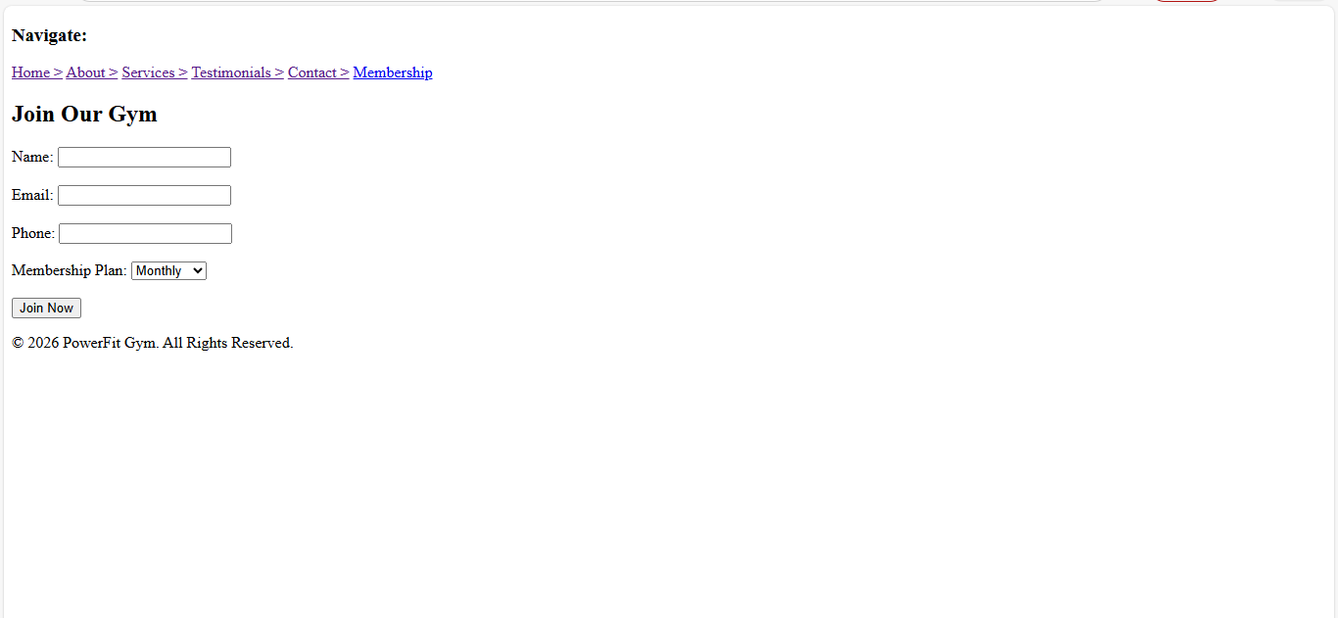

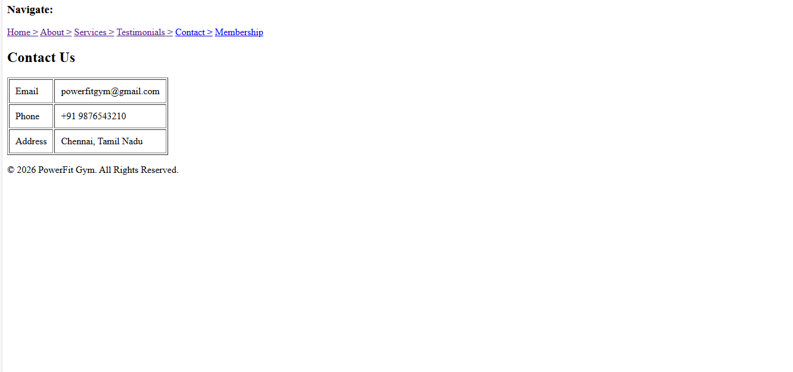
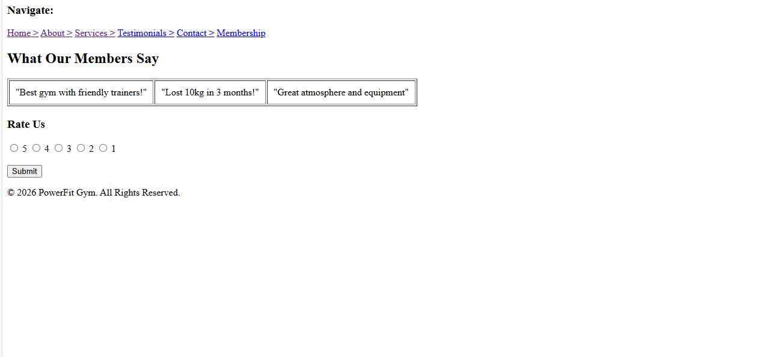

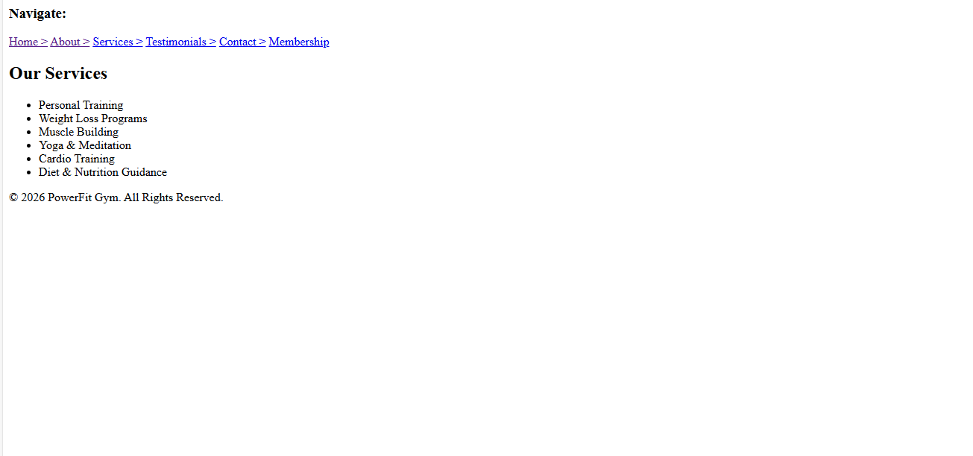

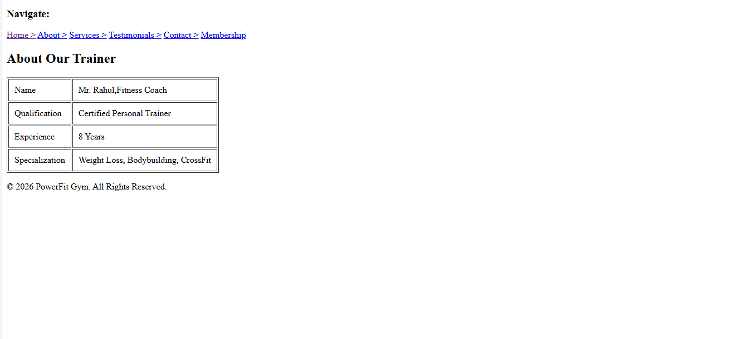

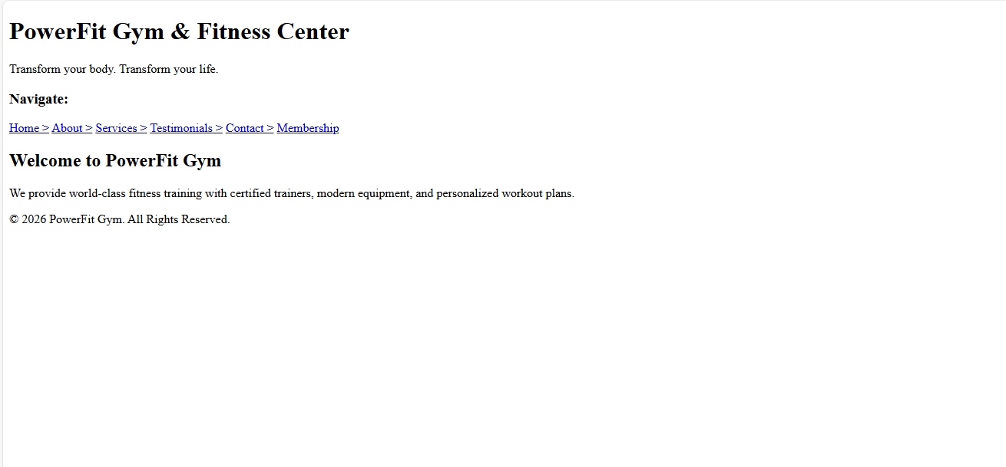

Result:
The Fitness & Gym Center website was successfully developed using HTML.
It provides information about trainers, services, membership plans, and contact details with easy navigation.

